Overview of JavaScript testing tools

Table of contents

Summary 2

Nightwatch (http://nightwatchjs.org/) 3

Compatibility with cloud services for cross-browser & remote testing (on Selenium grids) 3

Continuous Integration 3

Documentation 3

Extra’s worth mentioning 3

Example 4

WebDriverIO (http://webdriver.io/) 5

Compatibility with cloud services for cross-browser & remote testing (on Selenium grids) 5

Continuous Integration 5

Documentation 5

Extra’s worth mentioning 5

Puppeteer (https://github.com/GoogleChrome/puppeteer) 6

Compatibility with cloud services for cross-browser & remote testing (on Selenium grids) 6

Continuous Integration 6

Documentation 6

Extra’s worth mentioning 6

Nightmare (https://www.nightmarejs.org/) 7

Compatibility with cloud services for cross-browser & remote testing (on Selenium grids) 7

Continuous Integration 7

Documentation 7

Extra’s worth mentioning 7

TestCafé (https://testcafe.devexpress.com/) 8

Compatibility with cloud services for cross-browser & remote testing (on Selenium grids) 8

Continuous Integration 8

Documentation 8

Extra’s worth mentioning 8

Example 8

Cypress (https://testcafe.devexpress.com/) 9

Compatibility with cloud services for cross-browser & remote testing (on Selenium grids) 9

Continuous Integration 9

Documentation 9

Extra’s worth mentioning 9

Example 9

Honorable mentions 10

PhantomJS 10

CasperJS 10

# Summary

* Nightwatch and WebDriverIO are testing tools that need Selenium or a WebDriver to run tests.
* Puppeteer and Nightmare are libraries for web automation that need a testing framework like Mocha or Jasmine and a tool like Chai for assertions.
* TestCafé and Cypress are tools that work on their own thus have their own WebDriver

# Nightwatch (<http://nightwatchjs.org/>)

* Node.js based
* W3C WebDriver API for commands and assertions on DOM elements
* WebDriver implementations: Selenium, GeckoDriver, ChromeDriver, Microsoft WebDriver

## Compatibility with cloud services for cross-browser & remote testing (on Selenium grids)

* BrowserStack
* SauceLabs
* TestingBot
* CrossBrowserTesting (Smartbear)

## Continuous Integration

* Jenkins integration
* Gulp plugin

## Documentation

* Bundled on own website
* Easy to find things

## Extra’s worth mentioning

* Nightcloud: their own cloud testing service specifically for Nightwatch is being developed (<https://nightcloud.io/>)
* Nightwatch is integrated in Drupal 8.6 pre-release

## Example

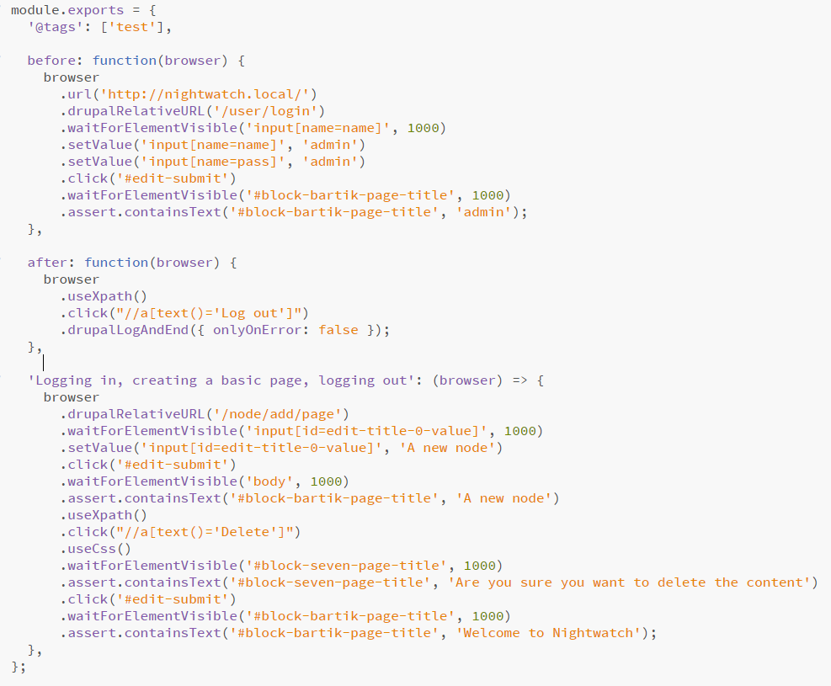

# WebDriverIO (<http://webdriver.io/>)

* Node.js based
* WebDriver implementations: Selenium, GeckoDriver, ChromeDriver, IEdriver

## Compatibility with cloud services for cross-browser & remote testing (on Selenium grids)

* SauceLabs
* BrowserStack
* TestingBot
* CrossBrowserTesting (Smartbear)

## Continuous Integration

* Jenkins integration
* Gulp plugin

## Documentation

* Bundled on own website
* Easy to find things

## Extra’s worth mentioning

* Popular
* A lot of integrations with other tools

# Puppeteer (https://github.com/GoogleChrome/puppeteer)

* Node library which provides a high-level API to control Chrome or Chromium
* (non-)Headless Chrome/Chromium
* Mocha (test framework), Chai (for assertions), Puppeteer (for browser automation)

## Compatibility with cloud services for cross-browser & remote testing (on Selenium grids)

* None, focus is solely on Chrome/Chromium

## Continuous Integration

* Can be integrated in Jenkins but didn’t find a lot of documentation on it

## Documentation

* Bundled on github
* Harder to find things

## Extra’s worth mentioning

* Provided by Google
* Faster than Selenium/WebDriver based tools
* Ability to create tests with DayDream

# Nightmare (https://www.nightmarejs.org/)

* Node library which provides a high-level API to control the browser
* Electron (headless browser engine)
* Mocha (test framework), Chai (for assertions), Nightmare (for browser automation)

## Compatibility with cloud services for cross-browser & remote testing (on Selenium grids)

* None, focus is solely on Electron

## Continuous Integration

* Can be integrated in Jenkins but didn’t find a lot of documentation on it

## Documentation

* All in one page on github
* Harder to find things

## Extra’s worth mentioning

* Faster than Selenium/WebDriver based tools
* Ability to create tests with DayDream

# TestCafé (https://testcafe.devexpress.com/)

* Node based tool to automate web testing

## Compatibility with cloud services for cross-browser & remote testing (on Selenium grids)

* Plugin for BrowserStack
* Plugin for SauceLabs
* Plugin for CrossBrowserTesting (Smartbear)

## Continuous Integration

* Jenkins
* Gulp

## Documentation

* Bundled on website
* A lot of documentation but scattered so it’s hard to find things

## Extra’s worth mentioning

* Easy setup
* One tool instead of WebDriver + assertion tool + web automation tool

## Example

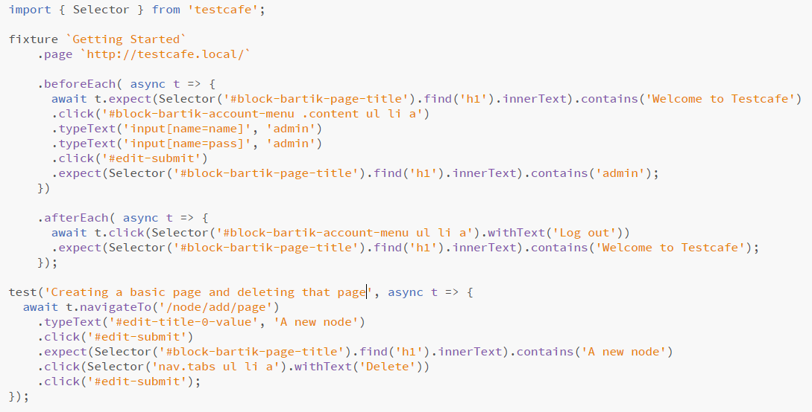

# Cypress (https://testcafe.devexpress.com/)

* Node based tool to automate web testing

## Compatibility with cloud services for cross-browser & remote testing (on Selenium grids)

* None at the moment only Chrome family
* https://github.com/cypress-io/cypress/issues/310

## Continuous Integration

* Jenkins

## Documentation

* Bundled on website
* Easy to find things

## Extra’s worth mentioning

* Easy setup
* One tool instead of WebDriver + assertion tool + web automation tool
* Ability to see tests run in application

## Example

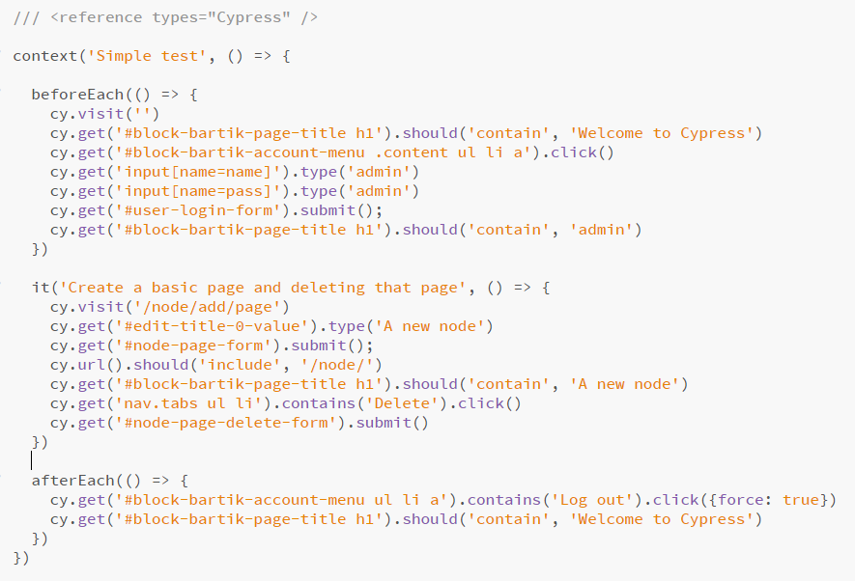

# Honorable mentions

## PhantomJS

The maintainer of PhantomJS stepped down because headless Chrome can replace it and is more stable and doesn’t eat as much memory. Therefore PhantomJS is unmaintained and no longer a viable option.

<https://groups.google.com/forum/#!topic/phantomjs/9aI5d-LDuNE>

## CasperJS

Navigation scripting and testing tool for PhantomJS and SlimerJS. PhantomJS is unmaintained and SlimerJS is considered experimental, so I deemed this not interesting enough to look further into.